wwv..•.graphicmaps.com

Africa

- .:
'.. ..
( .:
: I

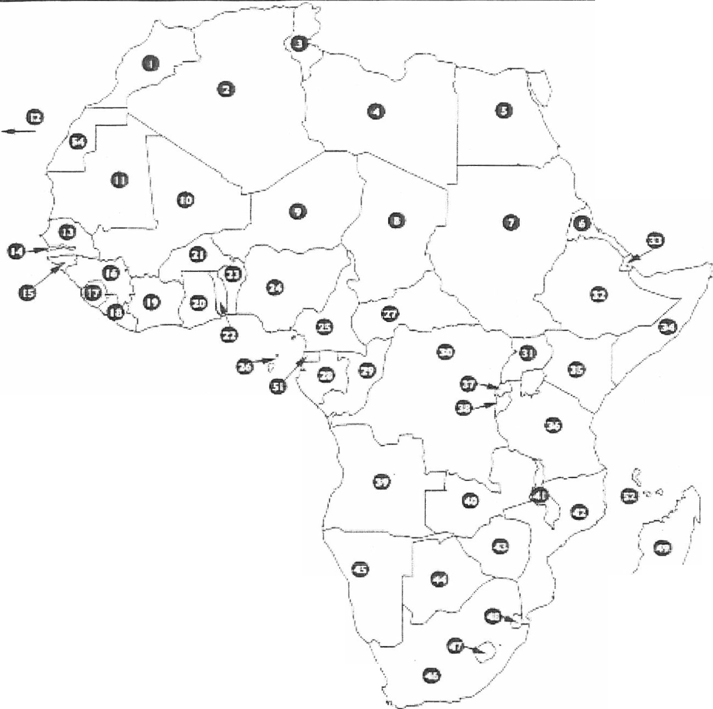

:
'
1,....__ .

Name the Country! ·•·.
•

G C) CD
8· G G e
•
0 4i· CD
0 e G
0 (D G (i)
0 e CD
0 ED G (j)
0 e 0 0
0 e. G ·
(I!) tD G
e e ttl e
m (D 0
CD G CD
0 CD

