------®
Blank Map of Oceania

,... 15tf E
f. \
1 1 I
1 : r
I I· '

,-,' "tJ ",.
.

,.---,

.... .1' \
\

'·

• C•l ..f •.'' /

.... .... -C-l •
,-.-...'

1- -- '
·.
D .. '/

"--------

'·'·=·,
,...., I
" .· ''·

'1""1 ,., --- • '
o ' '-. .., I a I - - - _, ·!• \
J'\i,,.o.r,r. ... '- ;...-.;-:.-... -._ - - - -- - - \- :·. '

.. ' .'.-.

..,. , I

.,. I
.I ,I
,.-....
I ..,..\'

'. ) ,.._.,., .. -- .
"" Ill • \ \ • Q• I •o• \ - - I

' ' 1- ..... ... , -·

\ ... •• I ......,._\
- \ f • \ / • • 4
! -: • • ,

' ,. '
. ·
, ,,,.I
..

.......
•..
_• I

- - ..- I .•\- . , • - •
-

- I I
I '\ "\; J
j
0

\.. 0 'I'/ I 1 .._
"I..
"(.,:a

\ 'Ill'-.: ....
'" ··' J I \ • t:l '• I,

'..... _..', ----
i _ ..
J T,npk .,f, ,/ • ·
":.\, _,

Ceq If icc.1 n ' • ••• ".".1t _,.
I a / '
' •••,.J-

...... -. -.'ftJ--.__··;---

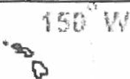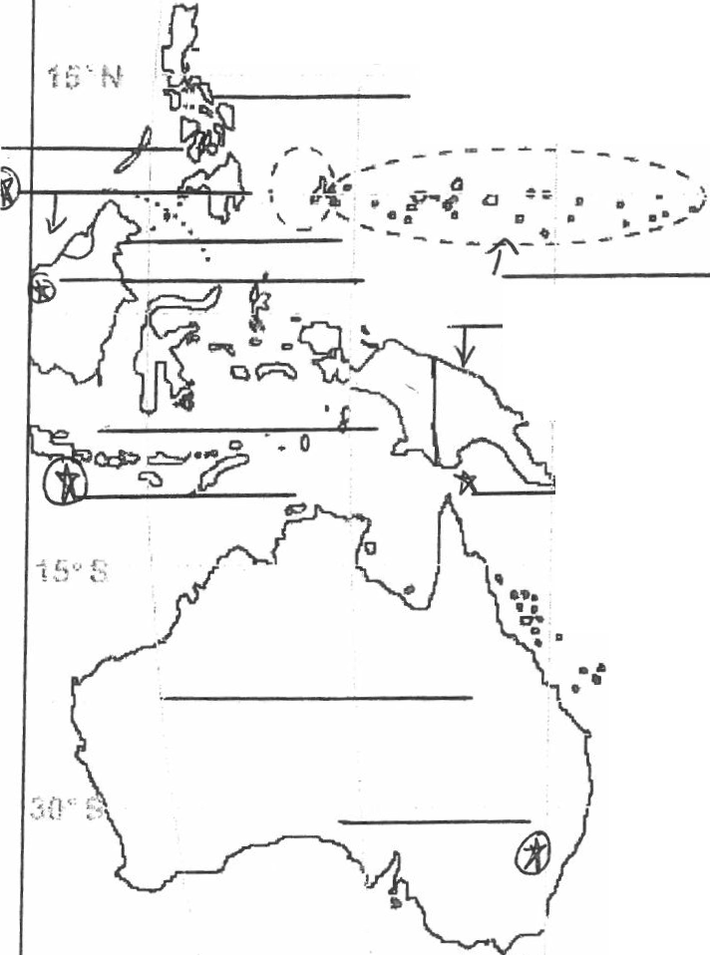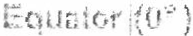

t3

0 1000 miles

1===:::::;-----'
0 1000 km
Jz .--@
---------------------

