9/J/20 14 samer .gif (520x811)

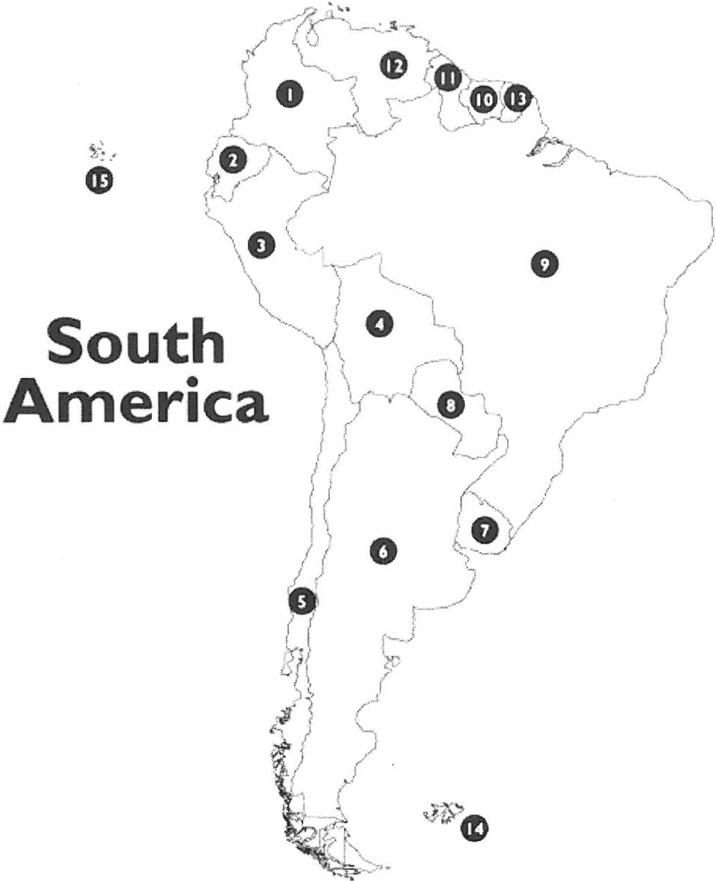
Name the Country!

0 0 $-----
0 | 0 |  | CD
0 | ------- 0- | -- | ----- --------

0 o e------
o·--- ------

Note that #'s 13. 14 and I5 are territories of other countries

http://www .wor ldatlas .com/wcbi mage/test maps/sanu.:r.gif Ill

