I •-

0

m 0

IJJ
'

111 The Physical World
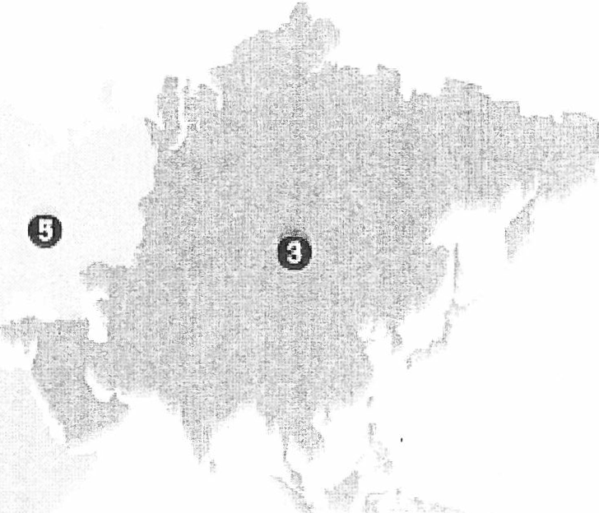Continents and Oceans

m

0

rn liTI 0

l'rt;)'''r:l hf! gr tphl<:mnr'"'· om
m G m

Name the Continents

Name th P. Ocean

0 (I
e
0
fJ m
0
0
0 rm
rn
[fJ.

