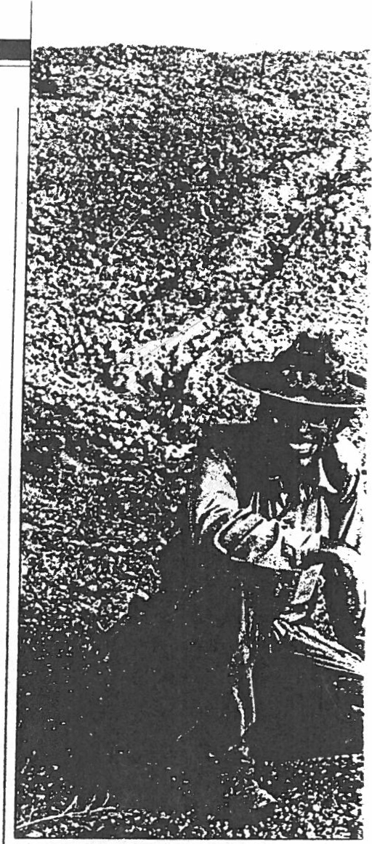Out of Africa,
a Missing Link

Science: The fossil of our unlmown ancestor is what researc ers expected. Its lessons aren't.

BY SHARON BEGLEY
CIENTISTS DREAM OF DISCOVER­
ing something that no one predict­
feet tall-are so perfectly positioned be­ tween humans and apes that Darwin must be smiling in his crypt. Members of the new

ed,
S
but anyone
can
make a splash
species, write its discoverers. "share a wide

with that sort of find. Anthropolo­ gists who study the origin of hu·
mans &ce a tougher challenge: to draw dra­ matic implications from the expected. Ever since the 1974 discovery in Ethiopia of the fossilofalittle protohurnan christened Lucy, it was clear u·hat sort of human ancestor must have walked the Hom of Africa just before her: one that was more apelike. Last week. in the -British journal Nature, three anthropologists announced what '{'imWhite of the University of Califomia,!JerkeTey, called "the oldest known link in the evolu­ tionary chain that connects us to our com­ mon ancestor with the [apes]." The fossils look almost exactl)"as everyone expected. But their implications for human evolution are completely unexpected. For the new species suggests that, at the dawn of human­ ity, what made us become different from the apes was a better way of raising a family.
It started with a tooth.On Dec. 17. 1992. as Gen Suwa of the University of Tokyo walked across the badlands of Ethiopia in Aramis, 45 miles south of Lucy's resting
array of traits with A. afarensis "-Lucy. But ramidus lacked some of"3:rmillron­ year-old Lucy's definingly human charac­ teristics . It had canine teeth comparable to ancestral apes', for instance. and an unmistakably chimpanzeelike skull. As paleoanthropologist Bemanf Wood of the University of Liverpool puts it in an accom­ panying commentary in Nature. ramidus "lies [extremely} close to the divergence between the lineages leading to the Afri­
can apes and modem humans ...The meta­ phor of a 'missing link' has often been mis­ used, but it is a suitable epithet for [this] hominid." Not that there was much doubt, but ramidus shows unequivocally
that, as White says. "Darwin was right :hu­ mans evolved from an African ape."
More surprising is how recent!_,,that hap­ pened. Ever since Darwin. anthropologists have believed that the lineage leading to lJowo sapiens and that leading to today's
African apes were rooted in a common an­
cestor. For decades they believed that our

last common ancestor lived 15 miUion to 20 million years ago. But then molecular biolo­ gists homed in. They compared blood pro­ teins in today's apes to blood proteins in human s. found them strikingly similar and in 1973 pronounced humans a lot closer to their simian cousins: the two lineages could not have split more than 4 million to

place, a glint from the ground caught his eye. "Iknew immediately that it was a hom­ inid"-a humanlike primate, he says."And because we bad found other ancient ani­
6 minionyears ago· • · .._, · ·• 5million ·· '· , ·.. " ' 41111111on _.
Roots of the Family Tree
 |  | .u: | - 'lll'.dl
 |  | ... | : '"'T't:l
 |  |  | - !

.

mals that morning.Iknew it was one of the oldest hominid teeth ever found."Over that
winter and the next, 'the 2Q-person team
uncovered additional specimens locked in
4.4 million-year -old sediment. coming up with teeth, arm bones and parts of a skull and jaw that turned out to hdon)! to 17 individuals. To the scientist s. thl·,· drar­ ly represented a new spet:ies. \\'hil c (codis­
.
) coverer ofLuc,·). Suwa and Berhane Asfaw
The fossils just discov red in Ethiopia come from
the oldest direct hwnan ancestor known. The new species, Australopith ecus ramidus. has features midway between apes and humans. It promises
to provide clues to still earlier e,·olutionary stage5.

HYPOTHESIZED COMMON ANCESTOR

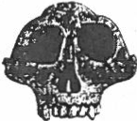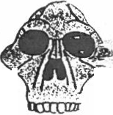Brain size: 400-500 mJ
-

- ' Molecular biolor,,· suggests the last com:::
- --- anc<>Stor of huma n o:.
African apes li,·cd
H;million years ag<•

Brainsize: 4Q0-500 ml

of the Paleoanthropology Laboratory in Addis Ababa named it Australopithecus ra­ midus. Austral opithecus )u-tbem ape": ramidus means "root."
The diminutiq• creatures -adults would have weighed 65 pounds and stood four

56 NEWSWE F. h O Cf O il; K :\ . 1 !:1!-14
Dlscovely. 1974 Site:Hadar. Ethiopia Features: "Lucy .- Full.·up­ right .lh·ed in family groups throughout eastern \irka .
'
!'."Very: 1924
te:Taung.South Africa
.

""""'•••"''"-' ·, •.:tures:Long arms. lij!hl . .
who liH•d in social group>.
":._!!d:desccndanl of Lucv
I

,.......,
0 MIU!S J00
find ha s put the nalced ape and the hirsute one on ever-closer branches of the genealogy. Ra­ midus confirms once and for all that the common ancestor lived just a little more than 4.4 mil­ lion years ago (chart). Humans are barely down from the trees.
Now the question is, what brought them down? There is wide agreement that walking upright, on two feet, was the fateful change that spurred the evolution of humans. It made possible quintessentially hu­ man traits such as tool use (easi­ er if you're not using knuckles to get around), a big brain (spurred by use of tools) and families (bipedalism allowed early humans to carry infants and food). Did rarnidus walk upright? Although the fossil hunters have not yet found any hip or leg bones that would clinch the case. two other bones are suggestive .A forward open­
change turned forests into savannas. onj these vast grasslands, say textbooks, natu­ ral selection favored creatures that col("· 1
get around other than by swinging fret ·
vines. But there's a rogue view, too. "I have
argued that bipedalism could only have evolved in a protected environment, like a woodland, not an exposed one,"says anato­ mist Owen Lovejoy of Kent State Universi- ty. "On a savanna, a creature just learning to walk, and therefore very slow, would have been exposed to predators."
Sharp teeth: Since learning to walk in a carnivore-filled forest is not exactly a pre­ scription for longevity, rarnidus must have derived a different advantage from the new posture. A clue to what that might be lies in its teeth . "In apes. the sharp projecting ca­ nine teeth are used as weapons of threat and display," ex-plains White. But ramidus had low canines that wouldn't have fright­ ened a kudu. So females must not have
chosen mates based on how convincingly they bared their teeth at rivals, argues
Lovejoy. Instead .females sought ouLmates who could help care for offspring; the best caregivers may well have been those who

CEI( st·w.,-l'I(IVt:IISITY OFTOK\.0
6 million years ago. (If they had, the pro­
teins would have diverged more.) This be­
came known as the "Eve" hypothesis, for
the woman who would have been the first humanlike child of that common ancestor. Anthropologists told these interlopers to crawl back under the test tubes where they belonged . But virtually every recent fossil
ing for the spine at the base of the skull and canine teeth smaller than apes' are both typical of later creatures that walked on two feet. Moreover, 1amidus's arm wasn't built for swinging through trees.
If it turns out that ramidus walked up­
right, then the implications for human evolution will be dramatic. Aramis was a thickly wooded flood plain 4.4 million years ago. filled with the chatter of colobine mon­ keys, prowling saber-toothed cats, brows­ ing kudu, pigs and bears.('The habitat may explain why humanlike fossils older than 4 million years are so rare: in a woodland, acid from vegetation destroys bones before they fossilize.) But the conventional wis­ dom holds that our ancestors did not walk upright -and thus take the first steps to­ ward becoming fully human -until climate
walked upright. using their hands to carry
food and infants. According to natural se­ lection, protohumans that became bipedal would have been more apt to mate, launch­ ing their genes for that trait into the next generation. "Lately, people have claime some pretty bizarre reasons for walking t right, such as reducing exposure to sola. radiation," says Lovejoy. "This discovery promises to wipe such claims off the slate."
The fossil hunters are returning to the field in November. If further finds conftrm that our oldest direct ancestor learned to walk in the primeval forest, it will push to center stage a''ery '90s notion:the crucial
spur toward becoming human was chang­
ing from a tooth-baring aggressive ape to one that carried home dinner and helped raise the kids.

  - : 3million ' 2 million . 1million Present
HOMO SAPIENS (NEAXDER1'HALENSIS) f/.t ;::.:•···.
., - - - - -.t\' :.:•·o.:.·.'·;
!:- - - - - - - - - - -
,,- - - - -.Ji ·. ;j. ..JtJ,: .:._' - J - -i!ffj

-c----- ---
-

- - - - -
" - - - HOMO HABIUS
HOMO SAPIENS (MODERX )

',_- • AUSTRALOPIT H ECUS AFRICA XUS
'',- - - - - - - - - AUSTRALOPITHECUS BOISEI
'
'- - - - - - - - - - • AUSTRALOP!THECUS ROBUSTIJS

I Homo erectus
l

Time span of species

- - Hypothesized evolutionary links

Homo sapiens (modern)

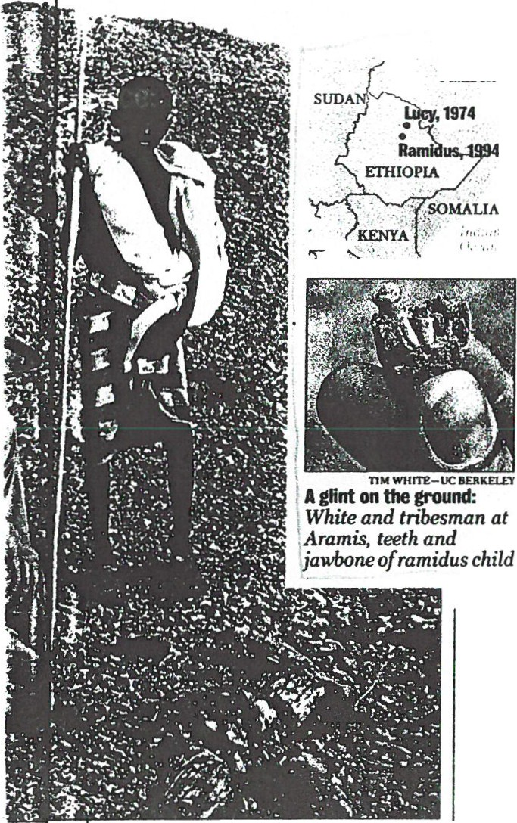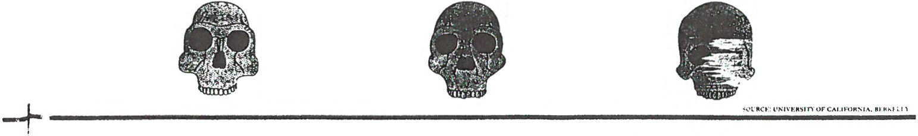lnllnsize:530 ml
lllsaMry: 1938
. Sib:Kro•ndraai S.Aftiw
fe: : $: Bra.vn;Pr
- .;uc1-: cf .:.friotJ'!:Js: !f'ft
O· ·.: ndants.
Brain sizt•:600-800 ml
Discowry.1960
Slte:Oiduvai Gorge, Tanzania
Features: First known
species in the "Homo.. f;;mily
of humans:first tool user.
Bnln size: 750-1.250 ml
DlsccMry; 1891
Site: Trinil Jav-..
Features: First SJA!< cs t:J
move out 0f Africa. colnnizinl{
the Middle East and to China.
Brain size: 1.2oo-1.iOO ml
DlsccMry; 1868
Site: Cro-Magnon , France Futures: Ponders its origins and evolution.

O C T O B E R j . 199 4 NEWS W EE K 57

1/S --0--C---I
: .. .. .,...... .•.
--E --T--Y----- ====== =================.

Jrhe 3 Million-Year-Old Man

"'. Science: A skull of the human family's oldest lmown member answers some evolutionary questions

Al' WHAT THE\" WILL ABOUT THE IM- new 3 million-year-old man suggest afaren­ portance of brains in research. in an- sis was as comfortable scrambling·around thropology there's no substitute for trees as walking upright on the ground .
S
sharp eyes and an easily stubbed toe. One The new fossil is startlingly similar to the afternoon in 1992.while a team of scientists oldest afarensis. For almost 1million vears laborioush• sie,·ed soil in the harshh·beauti - afarensis hardly changed. says Don.Jd .lo­ ful EthiopUm \'aile''· their Afar-tribe assist- hanson of the Institute of Human Origin s. ants com6ed a nearb,. hill. Suddenh-. one of codiscoverer of Lucv as well as the new
on
the Afar appeared the crest wa ·ing and fOssil. "Afarcnsis wis a very flexible spe- 1
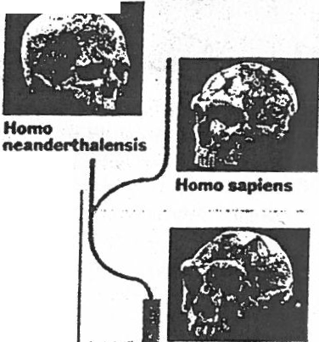shouting. The histrionics meant _.-......
only one thing:he had stumbled
upoo the grayish-white j!wbone

cies," adds IHO paleontologist \Villiam Kimbel. "Even as the local climate changed from humid to arid and back -a change that made other animals go e>.1inct-this little hominid adapted by learning how to use the new flora." Yet in the blink of an e,·olution­ ary eye, 3million ·ears ago. afarensis gave rise to no fewer than five branches of the human familv tree. Two led to brain\·. tool­ using Homo:three. to brawny australopithe­ cines that went ex1inct (diagram).When the IHO scientists return to Ethiopia this year. they hope to stub a toe on a human fossil from 2.5million to:3 million years old.Such a fmd could fill in the gap t>e'twccn ;tlarcnsis and the l)rst Homn species. Get rl'ady f(u· l..uc·y·s rand<"hild .

of a hominid, an almost-human of whom we are the direct descend­ ants. It took an additional gQ, months to excavate and piece to­ geuierwhat turned out to be more
than 200 rock-frosted fragments. but the anthroPOlogJstsareJmallyannouncingwhat inspired the euphoria: the first skull of the oldest lmown member of the human family.
Out of .Africa
A new skull disoovered inEthiopia strongly suggests the human family tree has one root:the species Australopithecus afarensis:, which livedjust after the human and ape lineages split.
0
Tim span.of IHypothesized .5
I
fossil speaes eVolutionary links

I.

The fossil. predicts paleontologist Leslie
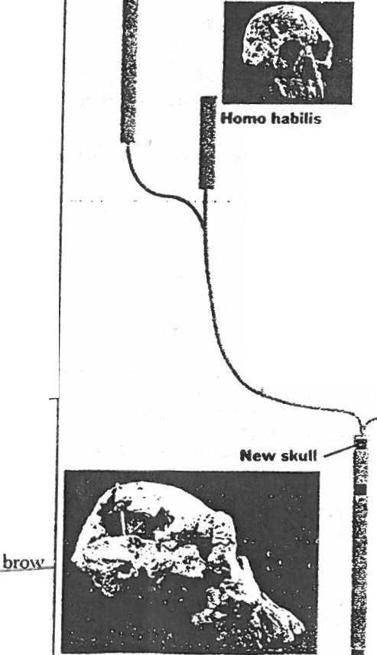Aiello of University College, London, could help Msettle someof the most heated contro­ versies surrounding ...the human lineage." One of those debates has been just how many roots anchor our filmily tree. The
.
new fossil belongs to the me species as

Homo erectvs

Australopithecus

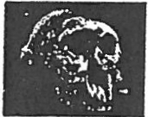1.0

boisei Austratopithecus

8.18millioy-xear=old Luc\'.the slender little
'cemaJe d a 'mile awa\' in 1974.
C"llled AustralgpitiLL>cus a.farensis. she was
the first of what now amounts to more than 300fossils from 75 indh·iduals. But the skel­ etons seem so diflerent- some as lithe as a
ballerina and others as brawny as a Uback.
some that seemed like simian tree c imbec;
and others that walked fully erect -that

nldolfensis . .· . • ..
Homo '·
·· robust us

2.0

some scientists argued they represent two species. The latest lind -call him f C.)'-supports the noti.)n that these fos­ sils. 3 million to 3.9 million \'Cars old .are all afarensis. argue the anth-r-;;pologi ots in the current issue of the journal Nature. It was
Austrato- Australopithecus pit ec!-'s
.J ••
nu··· ..j··· v, -
f' t:?.· I
I 1$. \ I

the first species to evoke after.the human and a lineages s£!!!: B·the e,·idence of theu:teei"h . afarensis ate fruit. in t>cts and small animals. The\' left no tools but may have used sticks as toda ··s chimps do to scoop termites out of nest s.
Son of U..c\· should also resol\'e what
\. ·.>\ c--.?--

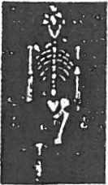lucy StJD.
}'--- ....

0 -IUU

:3.0

afarensis looked like and how they got around .He has a protrudin ·aw.thick ridges and a brain cas.e so small it leaves no doubt that our ancestors learned to walk long before they mastered complex thought.
The women topped out at fou t and
u d s. but their mnsort s grew to ti,·e (ect..

Ear4imknown Australopithecus
..; afarensis
e" ofa I''\SOMALlA
newskull '
7
" } ;
. :KENYA ;
•.

3.5

and 100 pounds . :\nd the ann bones of the c: ·;;;•orHu..A><<»oK.t:<s
III.LIO OF li.MIS AGO .U

84 N E \\' S \\ " r I

._,I' H t I ll . I ; .!

l'llt Jiot"li :ot\l i•H'It t i..J I"ItiM 11 \\IHI 111\ll i. l'"' l f l l :l•h 1/\'I\'•Jitlt,l'''!•

;' THE 444 SKULL
I!

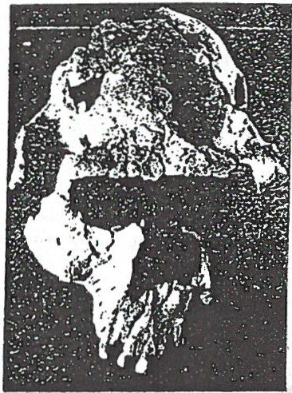very time an early human fossil is discovered on a Johanson expe­ dition.Tel Aviv University: pateoq­
E
r

chewing muscles that we had no evi­ dence of befOI"e," says Johanson. "and a number of teeth are worn down so
....-. .....

tologist Yoel Rak turns up his portable
r
heavily-right down to the dentine­

stereo and blasts the camp
I
.
w1th a
that it suggests he was eating very
tough . fibrous foods-that afarensis

recording of Beethoven's Ninth
i Symphony.And tha; tS just hOw Johan­ son f•rst learneo tnat Rai< himself had
made an imponani new find: a nearly complete skull oi Australopithecus a/arer.§_iS. humanity's earliest ancestot·-
lt took weeks of arduous work to clean. identify. and glue all the hun­ dreds of skull pieces that Rak had found. the barest slivers of bone prov­ ing sometimes crucial to the recon­ struchon. The result was the 444 skull
i
(named fOf the number of the Hadar fossil site where it was found) from a large male whO died in his thirt1es some 3 million year ·That makes 444 about
years younge than- h'fs older "sister.·Lucy. the most
famous memoor of this species .
Sc1entis ts have had fragments of afarens,$ skulls beforE. but this specunen 1s 75 to 80 percenl complete . with upper and lower jaws . a number of teelh much of the lace. and the lop.back. and bOttom oi the s%ull all re­ maining. "It has ver}' pronounced markings for substantial

was rncs;!y a plant ea:er ··
0:-. :. s; appearance. 444 •S a mas­ Sive sk t'. but it stil! has the small . ape­
like bra'" characteris!ic of afarensis Johanson tears. however. that its spe­ cial combination of features may once again generate intense debate as to
the real position Of this species on the
family tree. '"Some people may pick up
on the ent)(mous face. the large flaring
cheekbones. and the bone shell that reflects the massive size of the chewing muscles.·he says, "and view these traits in isolation. They may sug­ gest they are typical of only the robust branch of the human family (that d1ed out} and not the one that led to
man.- But Johanson po1nts to the fact that a number of
later skulls on the Homo s1de o! the fam1!y --the one that d1d evolve into human tx:•ngs-·-also l'l<'!ve mass1ve laces and considerable muscle rnark1ngs."We s1111 feel comfort­ able he says. "see•ng afarensis as the trunk of the human tree ."-Sharon McAuliffe

Ancient jaw found at new site

NEW YOrtK c AI' 1 - Scientists human predecessors in eastern and have found a 2+milhon-year;-<lld southerr. Africa .
; jaw from a close couslri oi mOdern The bone belonged to Homo rudol­
·1lumans outside of the well -known fensis. researchers from Germanv. fossil sites of Afr ica. revealing a Malawi and Hunter College in Ne-w

that area, he said. But while Homo rudolfensis stayed put. the others migrated to southern Africa only during warmer periods, he suggest ­ ed.

the new finding gives ; ddcd weight to that classification. Uromage said Scienti ts have not vet addrcsst•d whether Homo rudoifensis m;tdt• stone tools. h<' said . Homo habili s.

new place to seek remains of e< rly York write in the journal Nature .
The other fossil dated at 2.4 mal - . which is known from about two 11111·

:JUman ancestor s. Study co-author Tim Bromage of
The jaw is one of only two known Hunter College said Homo rudol · specimens thought to be as old from fensis may have arisen m Afnc"li" s the evolutionary group called -Rilt\lalley. which stretches from Homo, which includes modern peo- Ethiopia to Mozambique . partly in ple . homo sapiens. response to an unusually cool and
The fossil was found near the dry period some 2.5 mill1on years
western shore of Lakl! :'\lalawi in ago.
lalawi. The area lies bctw n the Other predecessor s of the human
.,,·ell-known sites for fo !l5 of early lineage also may ha"c ori!!inat£-d in
lion years and attributed to early
Homo is eight-<:entimetre scrap of
skull bone found in Kenva .
Homo rudolfensis had a bra in about half the size of that of'modern humans. as well as more powerful jaws and bigger teeth that modern human s ha\'e. Bromage said . Its ex­
istence as a distinct species has lx.-en proposed only recently . and
lion years ago. is generally consid ·
cred the first tool -maker. he said .
Eric rklson . :111 anthropologist at Lehman Coll<'ge·of City Univcr ity of New York . said the report is im· portant b<'cau s<' it rc\'ealcd a new area to look for rcmams of carh·
Homo. and bec;ause it and th
Kenyan fo sil upport l!ach other·
claim to b.! rl!mains llf t'arly 11om\'.

Pluto's bizarre orbit linked to past ·events

NEW YORK cAP 1 - What made Pluto's orbit so bizarre ':' :\ U .S. sci­ entist is proposing it was a gravita­ tional dance with Neptune back when the solar svstem was still
forming . .
!ptune could ha\'e pulled Pluto
-- - <>fa fairly circular orbit and put it into the more egg-shaped path it follows today. the scient ist says in

her study.
Pluto's orbit is unu sual because the other known planets follow al­ most circular paths . Pluto's path is so distorted that although it is the outermost planet for most of its 248· year journey around the sun .. it peri­ odically cuts inside of Neptune 's or­ bit before going back out again . ,.•
Collisions are avoided becau se tf1e

two planets orbit in a lockstep that k ps them away from each other. Pluto's orbit is also unusual in that it is markedly tilted compared with the orbits of the other planets . The reason for Pluto's orbit has long been a mystery. Some have su ggested Pluto is an escaped moon of Neptune. or that it alone survived wh1le many similar objects were de-

stroyed or hurled away by Nep ·
tune's gra\·ity.
The latest proposal is presented in the journal Nature by Renu Malho· tra of the Lunar and Planetary lr; stitute in Hou ston .
"I'd say 11 look s prett y good ...
commented Scott Tremaine . a pr(l · fessor of physics and astronom · :11 the Univer sity of Toronto .

•::1I 1II I•I I•II•I•II•II•II•-I.I•II•II•II•. •I:I .II•W•II I•I•II •II •II•••I•I I•II•II•I•II•II•II-.I•I .II•II •II •II •II•II•II•II -.-II.I•I I•I•W •II•W•I•I I•ll ••"•11. ••••••••••• •
-------======_... -:::::--=- GWZi

BACKGROUND INFORMATION: In 1959, Mary and
Louis Leal-.e · found a homin oid skull in the Olduvai Gorge in Tanzania, East Africa . They named their discovery Zinjanthropus man , claiming that he was over 600,000 yea rs old and was -a bridge between homo sapiens and a n cient prem en types previously discovered in South Africa. Their find was a remarkabl e one, but their immedi ate observations concerning it were not quite correct. Zinjanthropu s man proved to be far older than the Leakeys thought him to be; he is no longer believed to be a link between homo sapi ens and premen. According to the pota ssium-argon process of dating, Zinj anthropu s is about 1,750,000 yea rs of age.- Since h e was found , the Leakeys .have discovered remains of other, more ancient hominoid types.

The Olduvai Gorge, where the Leakeys have worked since the early 1930's, is rich with the remains of pre­ historic men and animals. Over two million years ago it was the site of a lake; then , in time, it became a desert; later, some 400,000 years ago, it became a swamp. Today, after many climatic changes and vol­ canic upheavals , it is a gorge set in the semiarid plain of west ern Tanzani a. When it was a lake, prehistori c men and animals gathered along its shore line and left their remain s which are being studied by the Leakey s today.

Besides Zinjanthropus, other hominoids found by the Leakeys at Olduvai includ e homo erectus, living over 500,000 years ago and similar to types found in Java and China, and homo habilis dating back almost 1,800,000 y ears ago. It is Dr. Leakey 's belief that Zinjanthropus and hom o erectu s do not figure in man 's devel opment and are evolutionary dead ends. Quite possibly , according to Dr. Leakey, it is homo habili s that is h eading toward s modem man. Much work re­ main s to be don e in thi s field .

The Olduvai Gorge has produced the remains of many ancient, extinct animal types. Many animals that lived .. by the old lak e were gargantuan in size; for example, remains have been found of a pig as big as a rhinocer-
ous, pelorovis , a six-foot sheep having a horn span of
four or five yard s, a giant baboon larger than a gorilla ,
and a giant ostrich-like bird that stood over twelve feet high. Perh aps one of th e most interesting animal finds made at Olduvai was the remains of a dinotherium , an elephant-lik e creature living 400,000 years ago whose tu sk s grew do\\'n from it s lower jaw rather than up, as in the case of mamm oth s or present day elephants.

Almost too m odem to m en tion is a prehistoric rhinoc­ crous that roamed the earth som e 200,000 years ago. Its skull was twice the size of the present day black rhino.

The Leak ey:- h ave onl y scratch ed th e surfa ce in the Old11va i Gorge. There a rc ulldoubtedly m an y prehi storic relics. hlllll<lll a nd ;Ul im a !. wait ing to be discovered.

rchttoloQiSts trading whisk brooms tor 1asers

witbout evet.Jetting a spade to earth." At Angkor in Cambodia NASA re- Western Ontario in London1Ont. "Or, we stone circles, recently abandoned a life-

By JOSEPH B. VERAEHGIA ·
of The As8oclated ··, ·· · , .
' ..... J't ' .. I

When British. arcbeQJogist ·Howard

C ern1 K!a(<TutaJikhaitlell's
v bisWtY.s ·lnoiit
tom '
A t......,.v iP.,t h methods are .re- searchel1 Uib)g a synthetic aperture might find nothing." .., · .: .., · l9ng index card syrrtem for a personal
....· . PN.es. !V·.at the ost fa- radar mo d·on a DC-8 are mapping· At the far end .ofTeotih a·s ere- computer..In mi utes, he·was able to
IDilentecl sites. · . .l.<m temples·oMcured by the dense for- epy Ave ue of the Dead,,f! rehers ··,co pare . . s1tes.th_roughout the
J!
t.-. ,m a ·irector,. Zahl . est canopy, as wen·as·a netwo of no have reassembled he r ·of BritiSh lsi atld.northe France..
. .tiett;Ves conventional dtgging · dry canals and·reservoir&:·In ·AD uoo, · peopl sacrificed 'durinJJ t! 1W1' ·Bur.l'S .n bOok, Great Stone Circles,
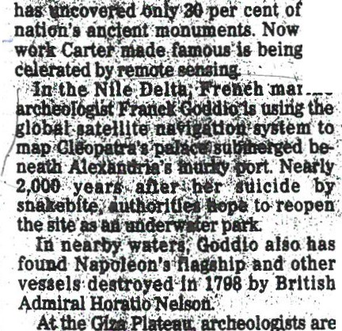200

hi. the
i ages suriesf, Angkor may have zenith in.AD
at·t}le:T e of bas
bad wA for the etoaked druids.

dazzii!lg cache_o lug·t6ol8
found eneri •ts.i
. . 'the , been ·the world's'largest city,.with one Feathered Se nt,or u U.. . ··n,. d:
t(t,i' lo:vers an ·:;tay-trlpping

nne screen .to sift10"Qilef.• saJWi sand
and wh J.barrowJI to c&i\ O!f
As tfie mm um .tti; l'J
in · · ··;thoU:
san s o er IU,"Cheo :trorld-

widrsfiU tayiJ e. . . .. o .<lost
civilization e· it &Uiii le'of

household utensils. ..,.;\; ·.. o'•' :
1 .¥.:. milli m le . · .. · , ·.. · Spenctfandothers:arh c!i;me wfl\l OckW .meplitbJ
- ) ;:,. Halt'W y ·at:bund<the . orfd ·in tlie'. lab methods t9 preservecHif evl- ·. -Bra worshiPPliii_ ancestors of "l·tfA,, .vaney'o Mexico; rtmt techilol®e8. detic&:-'-' DNA, .l>ciae .stele- lll.od·;B tons·are. UielY thought to 'arepelllhg :backthepasl :. ' '. tal traits- to reco tr e .s ory have hau ed its massi:ve stones hun -
Lat;e'ltris y_ear, reaearehers expect to b.ellin'd this Jmeieat·!S·: · · , dred (oH.i )Jtt tr .tfotn Wales, then pierce ttit- col'e·ofthe'Diasslve Pyramid or Many vlctinia · · · . ds. But erected ·them to preciSely intersect with

the·Moon; rh8Psreveattngthe'Contents none show broken rq,& tb ·con- the seasonal'journ.eys of the sun and
··ofaroyal tomb,tbatbas lain undistui'bed · ftrm historical accoutiU Qt tltig . moo·n. A-"lavely story," Burl sniffed . But

But the Victorian i e·ot a linen­
, sincettwassealoo2,«nlye8tsagb : . ·be!lrts being ·rfliped':froift' li sts ip look again. : · · · .

.. . ·not

a ircle at

suited scientist p\ll'SUltii.lOst lela 'With
- This part •ofthe job remains slow and homage to t e gods. "w.•thlnk they ·Stonehenge is
really

a w.h.isk broo bas bee!)::za pe(.}nto
obltvion by lasers an¢ pUticle accelera­

tor§. The searchfor ancient cultureS DoW i an expensive, high-tech enterprise that b"Orrows frOm space expioratiort matic :research i physics. ' Orbtting satellites dar likeelec­
tronic machetes ta"Clear" the juqles ·

that obscure long-burled ci ·and tombs. DNA analysis oJpummiea·alld skeletons determin i":tilnll)'-telation­
ships and h'\lmab miirltion patterns.

And electron microsco s examine the
silica skeletons of grain from hu- mankind's first harvests. ' ' .
"Men and women iri white cbats, toil­

ing away in their laboratories, have be­ come as important a··rugged field­ workers slogging away.under the·hot mn," said Christopher ·Scarre of Cambridge University in England. ·One
N i ,-- -z!.·:-::--"".tv allo.llas dirty.Blame it on th..e arehitec e. At were buried alive," SpJlnce . · all. he said:And, almost certainly its

·. ... n's..r:.t..-.!l)P':an!o_t e_r · Teotip justnorthofMexicei'City At> One doomed young nian •li&l to kick blocks are.leftovers ft'om the fee Age l'lrsk'entuey pyramids are b\lilt more'like his way to freedom. Disc'oV.&rint his that Neolithic engineers prised from
1
, a hug Tootsie Pop with layers of Unstable l,OOG-year-old agony wu Ullli ng. nearby fields:

us{ · · :' .. ,, , , . ·rubbleeoveringadeeplyburiedtomb . . "Sometimes at night,wbe..'you think :Moreover, Stonehenge's shape and gra: e n .:.... •f:·and:anb_ imatlon Burrowing into the Moon temple, about what you've done and·leen, it gets carvings are similar to those found in syitem tftau- hpu llc·wor arc eologists c n hear the'footsteps of kindof5pooky." Spencesald:·'!ouhear Brittany;\he we,stem province of mod-
. a suppo .t e Pyramids tounsts ascend1ng the same impossibly the echoes of some long-past g11ef." .,- ern-d&y France, Burl added .
t :tructionby20!00.0.l bo ers ore st- P · stairs· once climbed by as- .. Ofcourse,noteveryruinneedsl rs, . Stoneheng isFrench?
!!l't =l:;,••'.;. · -- · ·Pri•sts ond their.unlucky ,..,. robot• "•atellltes. unlder.stene- "Lwon\.""SIDnehenee • ..,._,,

thitrhlw o e. , lied in riflctal Vlctims. . benge, the ring of stone;pillaS. t has but 1t certainly is a hybrid," Burl said.
° .
al . iliriJs earliet roy- ' "We might find Tutankhamen of the .brooded over Salisbury Plain in Eng- ''The entire design is foreign. Itis a para·
br ken su1ft'et:e<I.. .m inal P.'auma, W st," said forensic anthropologist land for !i,<myears. . dox of construction and nationality ."
had syphibolineHs anddampukntations, ·So e Mtchael Spence of the University of Aubrey Burl, a British authority on In other words, still a bit of a mystery.
s. ow o we ow. Genetlc

an.IilnysrieBraun,.dUC.ST:SpCaatJhIS'O.·lo.gist$ using· CT ' SC&n$ determined .tbat .the'Ice Maiden, a mtunplY Of ail lp girl, died of a blOW to I the head as a htiman sacrif\ce yem ·1
  - r tb8n fl'eellngto death as was

day we may be able to excavate_ a site · mltially surmised. . '

