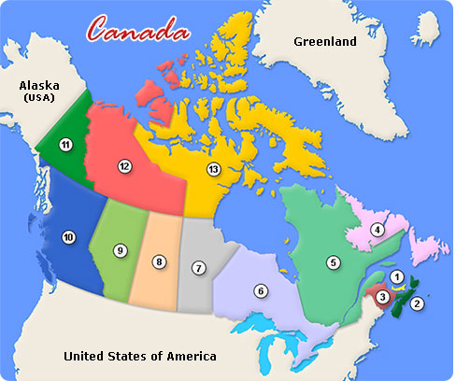

Place the following oceans and bodies of water on the map provided in their correct locations:

Oceans
- Atlantic
- Pacific
- Arctic

Capital City of Canada
- Ottawa

Bodies of Water

- Davis Strait
- Beaufort Sea
- Baffin Bay
- Labrador Sea
- Hudson Bay
- Lake Michigan
- Lake Erie
- Lake Huron
- Lake Superior
- Lake Ontario

Label all the provinces/territories and their respective capital city.
 | Province | Capital City
1
2
3
4
5
6
7
8
9
10
11
12
13

